StarCraft Base Defense

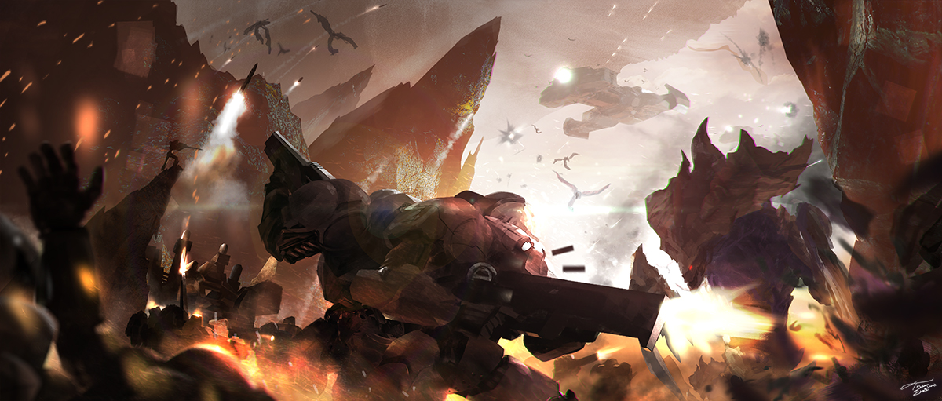

Figure [0]: Terran vs Zerg

Author: **Tyler Moore**

Course: Introduction to Virtual Reality

Instructor: Giuseppe Turini

College: Kettering University

Date: Fall 2019

## 

## Table Of Contents

**Table Of Contents** **1**

**Prologue** **3**

**Introduction** **4**

**Technical Features** **6**

Required Features 6

Optional Features 8

**System Design** **9**

Hardware 9

Metrics 10

Maps 10

**Technical Implementation** **14**

Immersive space marine perspective 14

1st Person visual perspective and models 14

Syncing 1st person camera with movements of animations 14

Visor HUD design and player stats overlay 14

Model hand movements using inverse kinematics 15

Player / model chest rotation syncing 17

Idle and run animations 18

Rifle interactions with controller 18

Player movement mechanics 19

Space suit / general audio effects 20

Space marine rifle mechanics 21

Space marine rifle shooting effects 21

Enemy dieing effects 21

Simple enemy AI 22

Space colony landscape design 22

Unit (player / enemy / buildings) health and damage system 22

Game Menus 22

**Scope Change** **24**

**Game Design V2** **25**

Restructuring the model 25

Handling player / model movement 27

Calibrating player dimensions with model 30

Heads Up Display 32

**Conclusion** **34**

**References** **36**

## Prologue

The design and scope of this project changed throughout its inception. Being that this was a learning experience I kept the original plans intact, so you the reader could learn from some of the pitfalls I stumbled into and have an idea of the original vision for this project. I hope this paper helps guide future students in their own project planning and increase their chance for success in this class.

This document is split into two sections, the first being my original plans, from the Introduction through the Technical Implementation. The second half contains the revised scope of the project and the implementation details of the new project design. Many thanks to Colin Gallacher, Giuseppe Turini, The Blender Guru, and Unity Technologies for making this project possible.

Disclaimer: This project was made as a proof of concept for my university studies and not for profit. This project is not a product of Blizzard Entertainment and is released under the GNU GENERAL PUBLIC LICENSE v3.0 and portions under the Creative Commons and Apache License V2. See the project file LICENSE.txt for more details. The entire project is available on my github: <https://github.com/devopsec/starcraft-base-defense>. Feel free to use this project and contribute if you feel so inclined.

## Introduction

StarCraft Base Defense is a concept Virtual Reality game where your task is to defend your colony from the Zerg onslaught. The game is based on Blizzard Entertainment’s award winning game StarCraft; set in a war-driven, futuristic space landscape, where survival is never certain. You play as a Jim Raynor, a Terran space marine who has been leading the fight against the Zerg army, until a fellow comrade Sarah Kerrigan was infected. Kerrigan’s mission is to destroy your colony and you are the last remaining hope we have. Good Luck soldier!

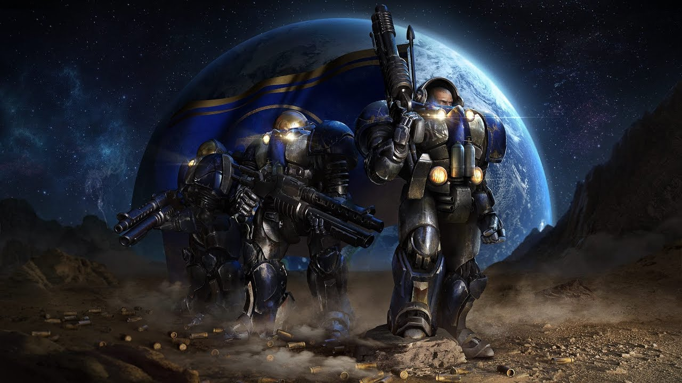

Figure [1]: Terran Space Marines

The player will be seeing from the perspective of Raynor. Wearable armor was considered for this project but will not be implemented as it will be too restrictive to the player. Immersion will be enhanced instead, by bringing the first person view point inside the space suit (the helmet and visor will be visible), viewable in the player’s peripheral view. Special attention to the space suit communications with headquarters will immerse the player in a realistic scenario. In the original game space marines had an iconic soundline that would play which sounded like real world radio communications through the space suit. There should be imperfections in the audio transmissions as would happen in space and the following [video](https://www.youtube.com/watch?v=d2t80SV54dw) [3] demonstrates the StarCraft audio effects that will be implemented in our version of the game as well.

Gameplay overall will be similar to many other “tower defense” games, where your objective is to defend your base until it falls. Enemy creatures will come in waves towards the player’s colony and when the colony loses a set amount of health points, the game is over. In the original game there was another race, the Protoss, which will be referenced in some of the assets / visual designs, but they will not be part of the gameplay and the main focus will be the Zerg race. As shown in Figure 2, the creatures are quite vicious looking and for some players could be uncomfortable to see running at them. To accommodate these players a short tutorial will be added where the player is introduced to the creatures before starting the action.

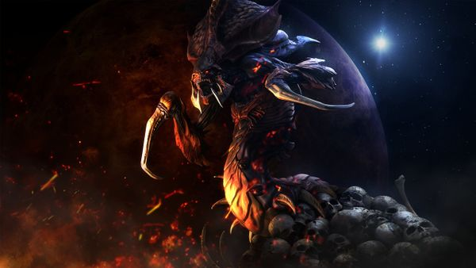

Figure [2]: Zerg Hydralisk

## Technical Features

### Required Features

1. Immersive space marine perspective
   1. 1st Person visual perspective and models 100%
      1. Head movements and rotation look great except clipping is seen with body at certain angles, need to scale model better
   2. Syncing 1st person camera with movements of animations 100%
   3. Visor HUD design and player stats overlay 100%
      1. Health stats
      2. ~~Ammo stats~~
      3. ~~Wave Number~~
   4. Model hand movements using inverse kinematics 100%
      1. Model rigging is not good enough, needs redone. Rigging was redone to fit humanoid bone structure and InverseKinematics2 was adjusted to work with the model.
   5. Player / model chest rotation syncing 100%
      1. This issue needs resolved by detecting what angle controllers are relative to front of chest and turning model after a limit is exceeded, something like > 45% should be a good approximation. This was changed to 30% as it has a snappier feel, when moving a lot. The player is generally turning fast and all the time during gameplay.
   6. ~~Idle and run animations 0%~~
      1. ~~Animations will need adapted for updated rigging.~~ New rigging uses humanoid rig and animations were scrapped because of this.
   7. Rifle interactions with controller 100%
      1. Holding rifle with both controllers (snapping to primary controller and stabilizing with secondary) 100%
      2. ~~Reload magazine interaction~~
         1. ~~Possibly may need charging handle interaction?~~
      3. Aiming with both hands (like a real rifle would) will require extra attention and may need to consider multiple fulcrums 100%
2. Player movement mechanics
   1. Model tracking w/ avatar and locomotion via movement and teleport 100%
   2. Movement also available using joysticks 100%
3. Space suit / general audio effects
   1. Player spawn and death audio queues 100%
   2. ~~Wave start and end audio queues 0%~~
   3. Enemy movement and attack audio effects 100%
4. Space marine rifle mechanics
   1. Shooting ray calculations and hit detection 100%
      1. Rifle is semi/full auto ~~so bullet spread needs considered~~
5. Space marine rifle shooting effects (controller vibration)
   1. Muzzle flash / smoke and bullet impact animations 100%
6. Enemy dieing effects (death animation, ragdoll, explosion)
   1. Zergling dieing effect using blood splatter animation 100%
7. Simple enemy AI (mecanim, nav meshes, path finding / enemy attack pattern)
   1. Zergling spawning in spawn zones 100%
   2. Zergling path finding algorithm 100%
   3. Zergling attack animations and hit detection 100%
8. Space colony landscape design
   1. Minimum one playable scene w/ spawn and movement zones 100%
9. Unit (player / enemy / buildings) health and damage system (critical zones / headshots)
   1. Health system for units (universal) and proper health scaling 100%
      1. Player HUD should display ~~all 3 (player,enemy,base)~~ health bar. Critical zones are being dropped for now (all damage uniform)
10. Game Menus
    1. ~~Simple usage menu with controller usage / HUD display explanation 0%~~
    2. Main Menu (with sub menus as shown) 80%
       * 1. Opening the main menu freezes gameplay 100%
         2. ~~The main menu will also be used in the opening scene (normally there would be options for selecting level there~~)
       1. Resume Game (resume game clock) 100%
       2. ~~Game Settings (FPS settings such as sensitivity)~~
       3. ~~Usage Info (see a.)~~
       4. Exit Game (simply close app) 50%
       5. Volume Settings 80%
11. Save Game Data 100%
    1. Ability to save high scores

### Optional Features

1. ~~Introduction tutorial~~
2. Loading / splash screen 100%
3. ~~Scoped in / Aim-Down-Sight space marine rifle mechanics~~
4. Bunker creation and usage (see original game for more detail)
5. ~~Support movement using motion sensors (running gestures)~~
6. ~~Space colony destroyed animation~~
7. Rifle Aim Down Sight effect 100%
   1. ~~When player ADS the HUD will display a crosshair.~~ The player will not have a crosshair show on HUD but will have the ability to aim down the iron sights using 2 hands.

## System Design

### Hardware

StarCraft Base Defense is being developed for the Oculus Rift platform running on the Windows 10 operating system, supporting i386, i686, and x86_64 architectures. Narrowly defining the scope of the supported platforms will make project completion achievable within a semester. The system will make use of the Oculus Rift S (standard package). A detailed view of the components is shown below.

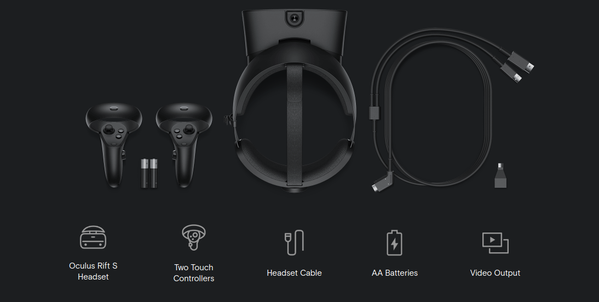

Figure [4]: Oculus Rift Standard Equipment

Oculus Motion Sensors will not be a hard requirement but is preferred for a better experience with in-game movement. Usage of the space marine rifle will be as easy as putting the Oculus controllers in front of the user’s body, as if holding an actual rifle, and pressing the right trigger button to fire. Reloading is similar to the real world action as well, all the user needs to do is move the left controller to approximately where the magazine is and move the controller away from and back towards the rifle (reloading the magazine). The last action the user can perform with the space marine rifle is a melee attack (with the butt stock) by making a quick forward, and backward movement on the right, and left controllers respectively. The rifle movement actions will be performed internally using the accelerometer to figure out which actions the user is performing. More importantly, the user will have access to all of the usage instructions in-game by pressing the start button on the left hand controller.

### Metrics

Several metrics will be tracked in-game and displayed within the user’s space marine helmet as a heads-up-display (HUD), such as; health, ammo, colony health, and time until the next resupply. Using the HUD display matches the futuristic time frame and keeps the perspective realistic without distracting the user from what is in front of them. Sound and visual queues will help the user understand when health is dangerously low or ammo is depleted. The biggest advantage over other “tower defense“ style games is the ability to move around the base freely, giving the feeling of a “free world” or “sandbox” type of game with the structured simplicity of a “tower defense“ game.

### Maps

For in-game movement players will have the ability to move in real time with oculus sensor tracking or with locomotion (like teleport) via the controller. The player will have the ability to explore and use the entire base; whether retreating or find a better offensive position, this freedom is a key feature for the game. A more in depth look is shown in the system diagrams overlayed on example playable maps shown below; Figures 5 and 7 being the maps before editing, and Figures 6 and 8 include the overlay.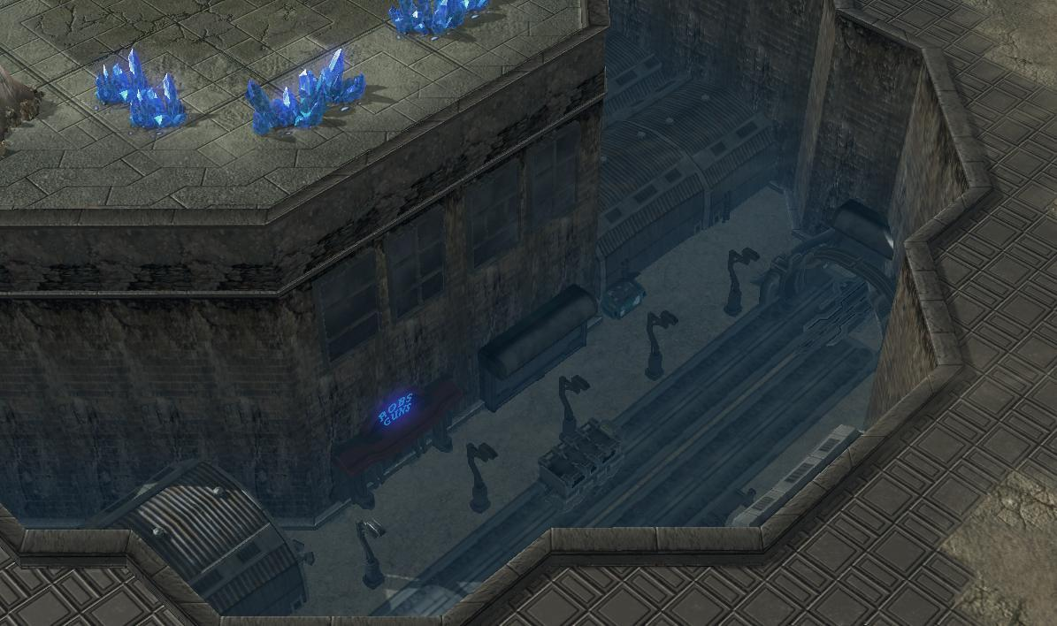*Figure [5]: Example map1 original*

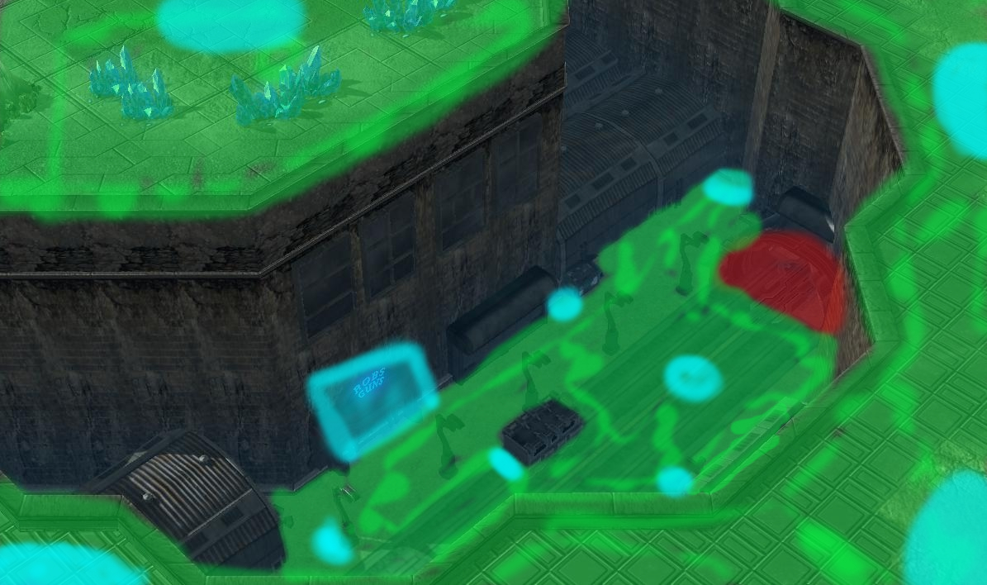

*Figure 6: Example map1 system diagram*

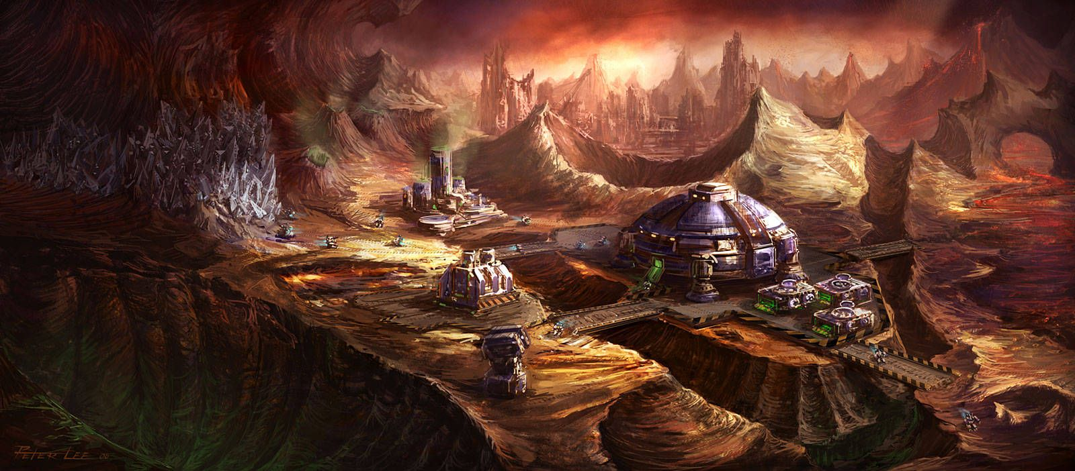*Figure [7]: Example map2 original*

Figure 8: Example map2 system diagram

The system diagrams are simply an overlay of enemy spawn points, player allowed areas, and player teleport / quick move areas, over an existing map design. See figure 7 below for more details.

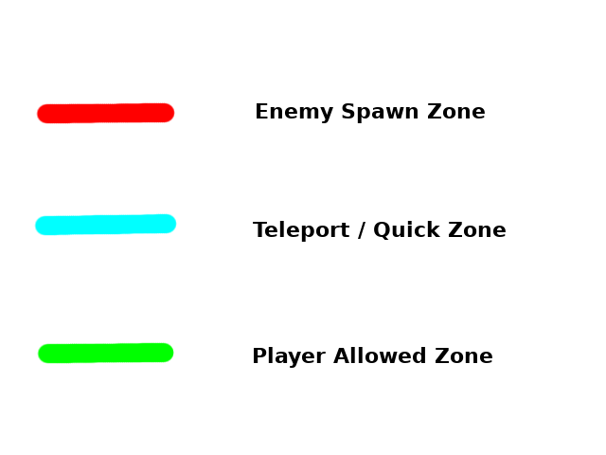

Figure 9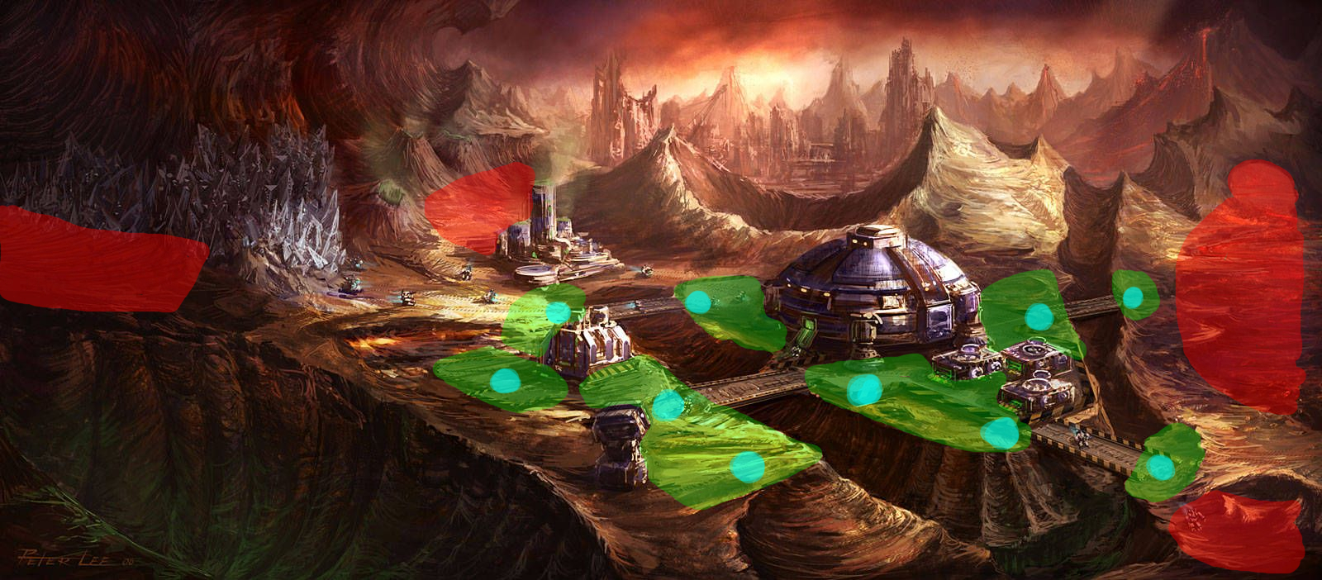: System diagrams legend

Map1 is a good example of a more restrictive and less realistic design, while in map2 the movement is more natural and the player has more freedom, but the downside is the increased reliance on movement in-game.

## Technical Implementation

### Immersive space marine perspective

#### 1st Person visual perspective and models

The players perspective is being built by taking the VR camera rig and tracking it within a model of a terran space marine. This is being setup by having the model track the position of the camera rig and separately tracking the models head to the movements of the players HMD (head mounted display). This works very well for the 1st person perspective but does not fully represent how a space suit works in real life as the helmet is usually stationary relative to the space suit and the person wearing the helmet could turn their head inside without moving the helmet. Depending on how this change would feel in-game, the helmet may be allowed to move relative to the space suit in the final version.

#### Syncing 1st person camera with movements of animations

The model being used is a prefab imported from a generous artist [6]. While this model is a very good start, including animations and rigging, it needs tuning to accomplish the 1st person perspective goal. The first issue is the proportions are quite large on the model and obstruct the players view in many cases, which can be fixed in Blender, a 3D modeling software. The second glaring issue is that the helmet is not built to fit a camera inside it and needs drastically re-proportioned. This was fixed by completely re-designing the helmet in Blender, making more space for a camera to fit inside the helmet. To sync this 1st person view with the animations available on this model, such as running and idle breathing, the helmet model was exported as a separate prefab and the position was tweaked relative to the space marine model, until the body stopped clipping with the helmet on animation.

#### Visor HUD design and player stats overlay

Now the visor of the helmet had to be addressed, as this was also not built for a 1st person perspective. The visor was also redesigned in Blender to match the new helmet model and to allow full coverage of the players unblocked (by the helmet model) peripheral vision. That works for the view from outside of the helmet but the view from inside the helmet needs to be translucent. To accomplish this the visors UV mapping and shaders had to be redone to allow light through the helmet. The principle shader is great for this task and the material was created using a slightly golden color and setting the shader settings to look like a reflective metal. Then transparency was added, using a lower alpha channel, which seemed to be work much better than trying to get a transparent shader to work in conjunction with the principle shader. Lastly the UV mapping was scrapped and a blank one was added to the visor. The visor in this state would look great from the outside, but the inside did not render because only the side normal to the face is rendered. The easiest solution to this problem was to flip the normals 180 degrees and add that duplicate visor model on top of the previous one in the game, making the visor visible from the inside and outside views.

Next task for the visor is to add the overlay of the players stats and game metrics, as stated in the Technical Features section. To accomplish this a UV mapping could be used with a dynamic texture or a curved canvas can track the object. Since the visor and helmet are already tracking the players position it is simple enough to add the canvas to the HUD as a child object and dynamically update the text elements. The rich text property will be used to get the glowing / projected effect on the HUD stats displayed.

#### Model hand movements using inverse kinematics

Players need to be able to interact with objects in VR using their controllers as hands and now we have to find a way to map this movement to the models hands as well. This is being implemented via inverse kinematics, essentially the models hand movements track the players controllers, then the models joints and bones are moved to a position that would match the movement of the hand. The usual implementation described in Unity Animation Essentials by Alan Thorn involves using the OnAnimatorIK() method of the modes animator, but this only works for humanoid models and unfortunately, the model being used is not rigged properly for this. Instead a custom script was made that translates and rotates the arm bones and joints manually on update(). This works well for models with good (human-like) proportions between the joints and bones of the model, but again, the model we are using seems to lack in this aspect and the result is a very limited range of movement. Figure 10 below shows how the animator updates the rest of the bones and joints to match the position of the hand.

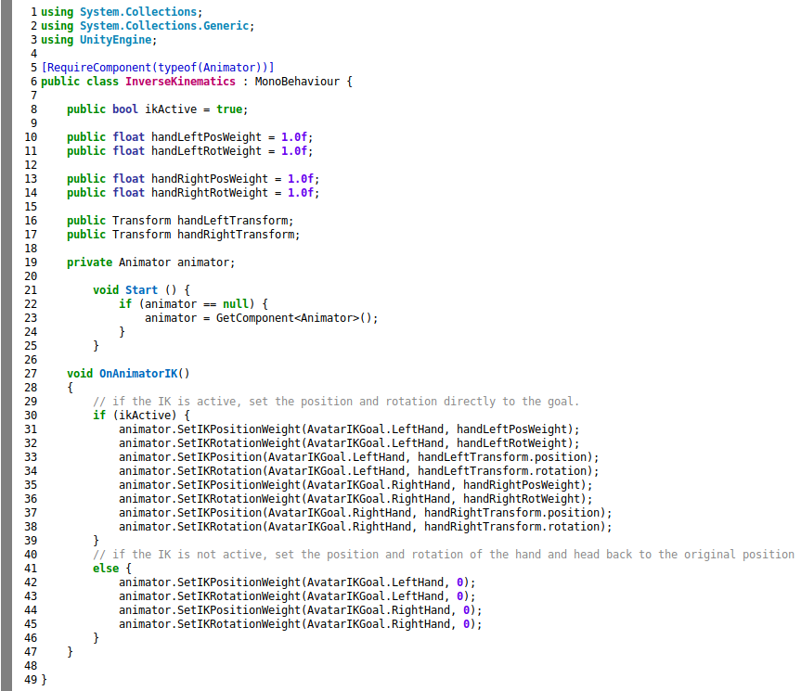

Figure 10: Inverse Kinematics Version 1

Inverse Kinematics V1 script did not work for the model being used due to the humanoid requirement, as mentioned earlier, and the implementation was changed in Inverse Kinematics V2 to a custom solution, as shown below.

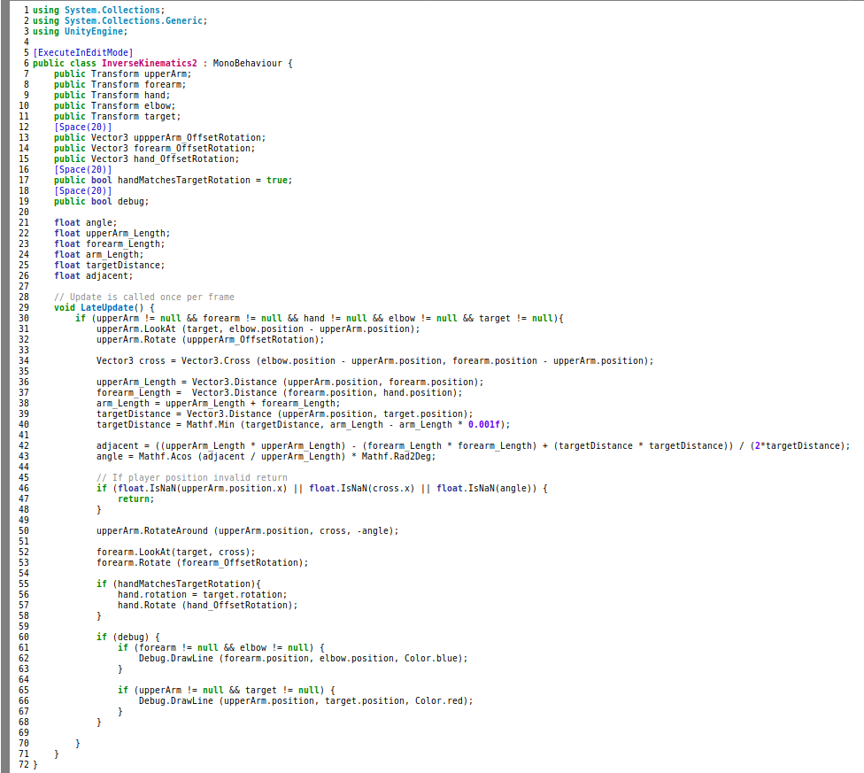

Figure 11: Inverse Kinematics Version 2

Moving forward the model rigging will have to be customized to work more naturally or to work as a humanoid model in Unity, which will likely break animations created for the model. Although the animations that were baked into the model are well done, only the idle breathing and running animations are necessary for this project and should be relativity easy to recreate for the custom model.

#### Player / model chest rotation syncing

One issue that is immediately noticed by the player at this point is model rotation. The decision at this point to track rotation of the model with rotation of the VR camera rig was not turned on, instead the helmet rotates in sync with the camera rig. This presents an issue that if the model tracks rotation as well, then the player could move their head in the real world slightly to one direction and the model (including helmet) would all turn that way, changing their perspective view from inside the helmet. This is not how it works in real world and feels wrong from the players perspective. Also consider that if the rotation of the model is tracked in all 3 cartesian coordinates then the player will float around the origin of the model, which is unacceptable. So the solution to both these issues is to track the rotation about the Y axis only when a certain angle has been reached, which can be a good approximation of when the payer would turn in the real world. Humans can’t rotate the head more than 90 degrees about the Y axis so that is certainly the maximum. Instead of using a constant degree the point at which the player turns can be better approximated by also checking where the players hands are facing, relative to the front of their chest, about the Y axis. The implementation will use a custom tracking script for the model, checking the rotation about the Y axis of both the camera and the controllers.

#### Idle and run animations

These animations were included with the original model but as stated earlier may need redone after redoing rigging. This can be by using keyframe animation in Blender. The idle breathing and run animations will try to be recycled in the new versions by mapping to the frames to the new model. If that does not work a simpler version will be created where the model body moves up and down for idle breathing and the leg movements added for running.

#### Rifle interactions with controller

The player will need to interact with their weapon in VR similar to in real life. This will be accomplished using controller interactions with the rifle. One issue that will need to be fixed is the rifle model we have is a single set of vertices and will need to be separated at the interactable areas into multiple models using Blender. Once reimported the controllers will have scripts attached that perform an action when interacted with certain colliders on the rifle. The important interactions for the rifle would be reloading the magazine, pulling the trigger, and stabilizing the upper receiver. Two handed interactions with rifles in VR can become complex in terms of aiming and stabilization so to simplify this aspect the players right controller will automatically snap to the rifles trigger assembly area and will stay there throughout the game. This makes aiming simpler, in that the players right hand is always the origin for the angle of the rifle and the left hand can make slight changes on the rifle position from there. With this setup the rifle will have 3 degrees of freedom at the trigger assembly and at the upper receiver and shooting the rifle will be accomplished using the ray created from the difference of these two locations continuing towards the rifle barrel until it intersects with a collider.

#### Player movement mechanics

Player movement is accomplished in one of three ways; real world movement of the player, moving one of the controller analog sticks, or teleporting by pushing down the left analog stick and pointing to a teleportable location. Real world movement is already baked into the VR camera rig provided by the VRTK SDK. Movement through the analog sticks happens by simply mapping the controller analog sticks to the player movement, which is also baked into VRTK. The model also tracks the players position so their perspective stays the same while moving.

The last form of movement teleporting, is accomplished using the VRTK blink or dash teleporters. The VRTK SDK includes demos of both of these types of movement as well for reference. To set this up in unity the VRTk pointer and bezier pointer renderer are added to the left and right controller objects, as shown below.

|  |  |
| --- | --- |
| Figure 12: VRTK Pointer Script Settings | Figure 13: VRTK Bezier Script Settings |

A teleporters object is then created that points to 2 more game objects that are created, the blink teleporter and dash teleporter, as shown below. The **B** button was chosen to toggle between the two teleport modes, allowing the player to pick whichever is desired.

|  |  |
| --- | --- |
| Figure 13: Blink Teleporter Object Settings | Figure 14: Dash Teleporter Object Settings |

Figure 15: Teleporters Object Settings

#### Space suit / general audio effects

The most important sound effect for an immersive experience in this game is going to be radio transmission from command center in the players helmet. The sound effects from the original game are very well done but may not fit the scenario well as they are from a different perspective, the player is the commander in the original game and in this implementation the player is a soldier on the front lines. If at all possible the original sound effects will be used but if there is not enough material to use then the same effect will be reproduced and recorded. For these helmet sound effects to sound more realistic the audio source will be configured as a spatial blend and spread out between the left and right channel of the players audio output (generally the HMD). Other sound effects such as unit death, unit movement, enemy attack, and player shooting should be configured as an audio source in 3d space from the source of the audio. These sound effects are plentiful in the original game and can be reused here as well.

#### Space marine rifle mechanics

To further iterate on rifle mechanics, the ray calculations mentioned earlier are the bulk of the problem but the player is shooting in full auto so bullet spray needs to be considered. Since the players movements are not perfect there will be instability inherent to shooting but this will likely need some additional spread as the player holds down the trigger longer because recoil can not be reproduced. To implement this an addition to the shooting script will be made that increments a counter over time and that increases the offset of the trajectory ray from where the player is aiming. The orientation of this offset will be random degrees of difference from the original shooting ray. Lastly, bullet drop and wind will not be considered in shooting mechanics for this game.

#### Space marine rifle shooting effects

For shooting effects multiple animations will be used including; muzzle flash, smoke from the barrel of the gun, and bullet impact. There are many assets with these animations on them already and those effects will be reused. Once found these effects will be mapped to the rifle and impactable models and triggered when shooting or collided with.

#### Enemy dieing effects

At this time the only enemies being implemented are zerglings which will need a killed animation. The model that will be used does not have animations so a short dieing animation will be created. When the zergling death is triggered the death animation plays to the end and then enemy game object is destroyed. The animation will essentially be the model fading and a blood splatter from where it was.

#### Simple enemy AI

The enemy AI is essentially 2 parts; the spawning of enemies, and the attack sequence of the enemies. The zergling will spawn at a set number in the spawn zones when a wave starts. The enemies will then use path finding, implemented using the A* algorithm, to reach the closest building in the players base. After reaching a building the enemy will attack it until destroyed and then look for the next closest building again, repeating this cycle. Enemies should also detect if they are close to the player and if they are, will attack the player instead of the players base. A special use case may occur when the enemy is near the player but there is no path to the player, such as in a bunker or in a tower. If there is no path to the player the enemy will continue towards the base and attack that instead.

#### Space colony landscape design

Since modeling realistic large buildings and all the complexities of the players base will be out of the constraint for this project, the models for the base will be pulled from external artists. A terrain will be custom created to allow some space between spawn zones and the players base. Teleport zones will be added to any locations that should be accessible by walking to such as bunkers and rooftops. If the area warrants it, invisible walls may be used to deter players from walking over some areas such as over the rooftop edge. Areas that should not be teleportable will all be marked as a non teleportable location as well.

#### Unit (player / enemy / buildings) health and damage system

The health system will be very basic and critical zones / headshots will not be considered. All units including buildings, will have a fixed number of health points. When the unit is attacked, health points decrease and when health is zero the unit is dead. This will be implemented in the character script as a simple float value. Other scripts will rely on this script for updates such as health bars on the player HUD.

#### Game Menus

There will be 1 game menu created as a prefab and reused as the start screen when the game is loaded, and as the players game menu. The start screen will essentially be a seperate scene with a white background and the main menu displayed. Opening the menu in game will pause the game, which is implemented in Unity by settingTime.timescale = 0. Closing the menu will unpause the game, effectively setting Time.timescale = 1. The main menu will have the following buttons: start/resume game, controller settings, and exit game. The first buttons text will be changed according to whether the scene in start scene or main scene. The exit game button will simply close the application. The controller settings button will open a sub menu with each of the controller button mappings and if time permits a graphic with the mappings overlaid on each button. Controller mappings can be changed from this sub menu and should be stored permanently for the player.

## Scope Change

The original scope of this project became understandably too large to complete in the timeframe of one semester due to several complications during development. The primary goal of this project was to create an immersive first-person virtual reality experience from the viewpoint of a terran space marine. This was the quintessential issue that needed to be solved and ultimately caused a change in scope. To implement this immersive experience the player’s camera had to fit inside a 3D model of a space marine and the model had to interact with the world as the player does. This proved to be much easier said than done.

I had also planned to use maps from the Starcraft campaign for the design of the levels. My workflow was to export the maps using CASCExtractor [8], import the models to Blender using blendm3 [9], and then export to Unity for use in game. These tools seemed promising but I was unable to get them working in the end. Nearing the third quarter of the semester with these two major complications, along with many smaller issues, I decided that the scope needed to be simplified drastically.

To keep the main idea alive, I opted to adapt a Unity tutorial shooter to fit the bill. Since the main proof of concept for this project was to create the immersive VR experience with an interactive 3D model, this seemed to be a good avenue for cutting out some of the “easy lifting” per say, and allow me to focus on the VR aspect of the project. The Survival Shooter [10] tutorial project is a now deprecated Unity tutorial project that walked you through creating a third person arcade-style shooter.

This had been my backup plan from the start of the project but I quickly found that the Assets were not available on the Unity Asset Store anymore so I had to get creative. I was able to find a project by Colin Gallacher [11] that was still available with the assets and this served as my template. Much of this project had to be updated and changed though due to the deprecation of many of the Unity packages and functions used in that project and to support the Oculus Rift. The next section details the implementation of this new project scope.

## Game Design V2

The new system design was based around the immersive perspective, fixing the deprecated tutorial project, adding Oculus Rift support, and improving general gameplay. The requirements for this design are detailed in the updated Technical Features section of this document. More detailed comments about the smaller design decisions are updated there as well. In this section I will choose to focus solely on the player perspective as it was the most important and difficult set of issues to tackle.

#### Restructuring the model

Immediately I ran into issues with the model from Elisey. The proportions were not made to be human realistic and therefore the rifle and shoulders were occluding the players view. The marine helmet was also not made to actually fit a humans head in it, so all these parts had to be customized. The rifle was scaled down in Unity easily but the model had to be edited in Blender, due to the complexity. This process was something not taught in class so with the help of Blender Guru’s tutorials I was able to make some usable models. For comparison here is the model before and after:

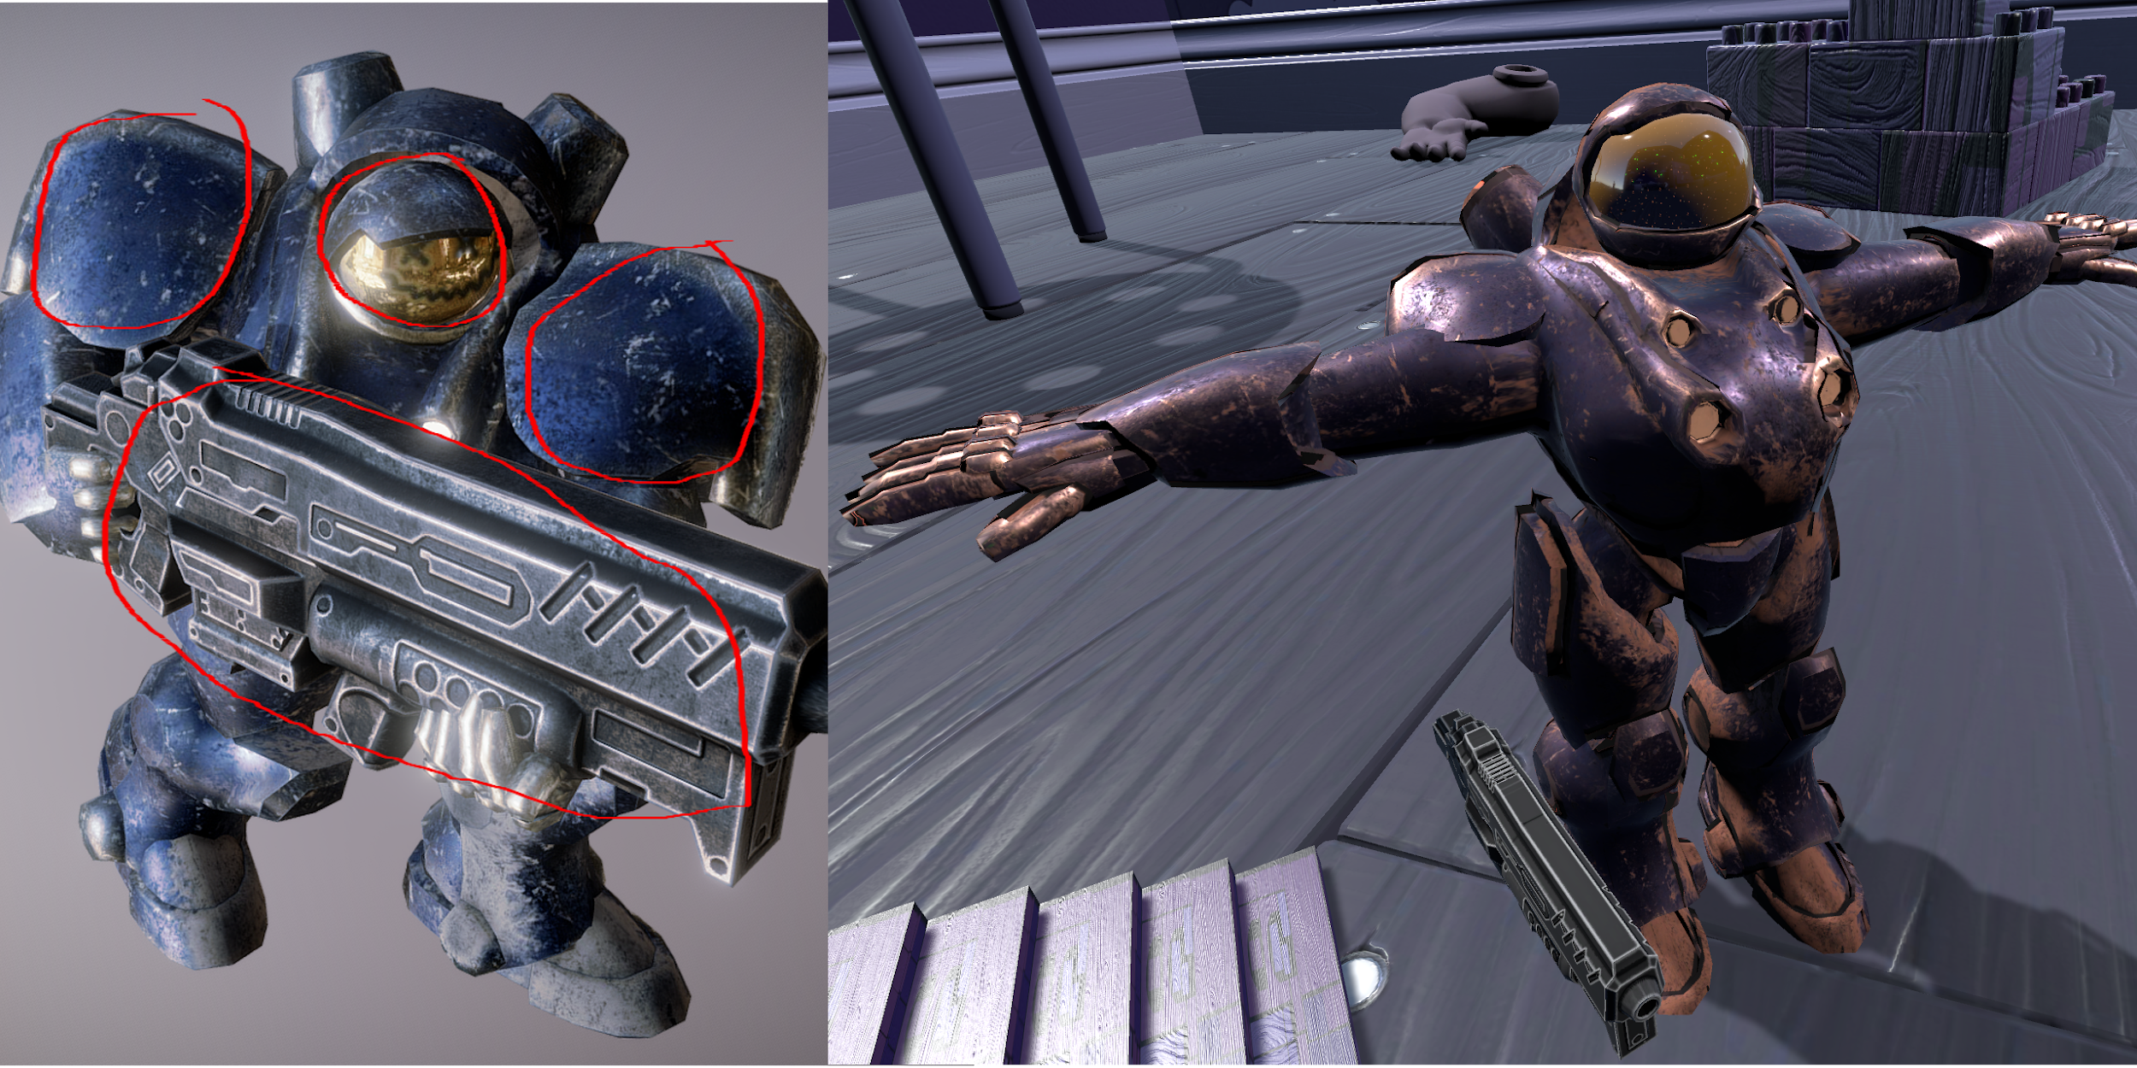*Figure 16: Marine Model Comparison*

Changing the structure of the model caused the UV mappings to be distorted and therefore the textures were basically random noise. The next step was to create a new UV mapping from scratch in Blender by a process called UV unwrapping, and then apply new textures to the models. Once the seams are correctly marked a proper UV mapping is created the textures will apply correctly. Below is the marine visor after unwrapping:

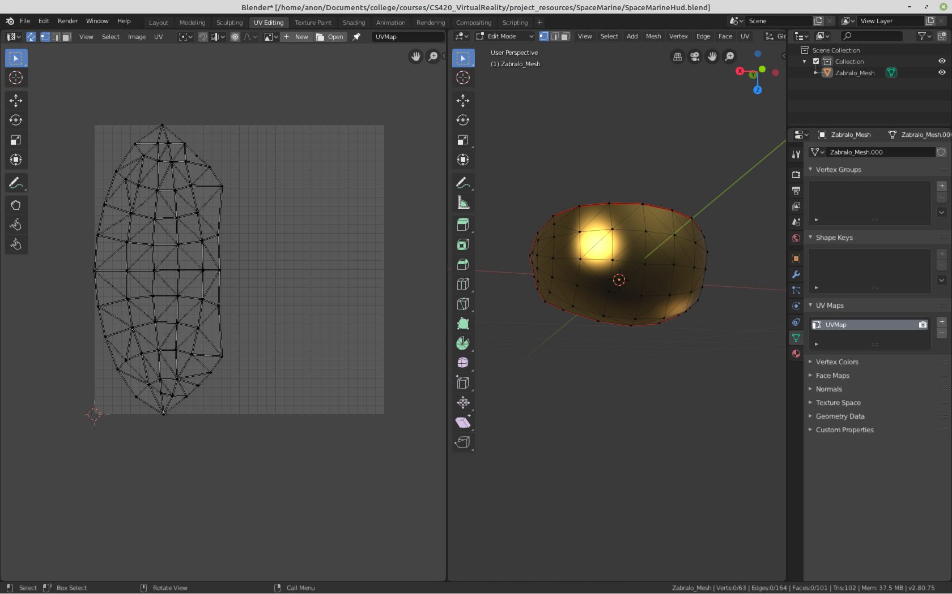*Figure 17: Marine Visor UV Mapping*

The next step is to render the opposite side of the visor, without doing this the visor is only viewable from the outside and I needed both sides rendered since the player’s camera will be inside the helmet. This can be accomplished either with some fancy shader work, which I am not well versed in, or the easy way, by flipping the normals. In Blender I made a copy of the visor and flipped the normal vectors, and simply placed this model at the same location as the outward-facing visor. The inside of the visor was also textured slightly different with some smudges and a faint grid to give it some realism.

#### Handling player / model movement

I now had a model that I could work with but no motion. To solve this problem I decided to use inverse kinematics as noted earlier in the document, but the rigging for this model was not created to be human-like so every attempt I made failed. To solve this I had to fix the rigging in Blender and remove the animations and poses from the model. I attempted to create the inverse kinematic constraints in Blender like Royal Skies shows in his tutorial [12], but was unsuccessful. Since rigging is a more advanced topic that I had no experience with it could have been any number of factors. I opted instead to normalize the current rig on the model to fit a humanoid rig when imported in Unity, then script the inverse kinematic motion instead. This is what the bone layout looked like in the end:

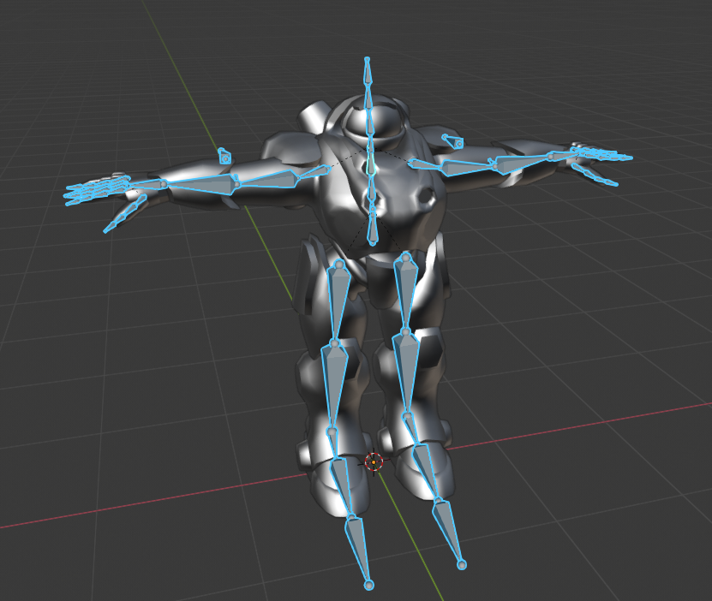*Figure 18: Marine Rigging*

After tweaking rotations of the upper arms, forearms and hands set in code, the InverseKinematics2 script matched player movement fairly well.

Now I needed to setup player and model synchronized movement. I am using the VRTK SDK to handle commands from the Oculus and move the player, which simply creates a camera rig object and collider that servers as the player. To make the model match the player I created a camera follower script which updated the models position and rotation to match the camera rig in game. This would be easy to implement using the VRTK_TransformFollow script from VRTK but it was missing a few things. In a real space suit you can move your head around without turning because the helmet is actually fixed to your spacesuit, and with this primitive implementation this was missing. To implement this I separated the helmet from the marine in Blender and created a custom script that would manage the body and helmet individually. The pertinent code looks like this:

|  |
| --- |
| protected override void SetRotationOnGameObject(Quaternion newRotation)  {  Vector3 oldAngles = transformToChange.rotation.eulerAngles;  Vector3 newAngles = newRotation.eulerAngles;  if (!rotAboutXEnabled) {  newAngles.x = oldAngles.x;  }  if (!rotAboutYEnabled) {  newAngles.y = oldAngles.y;  }  if (!rotAboutZEnabled) {  newAngles.z = oldAngles.z;  }   if (debugEnabled) {  Debug.Log("Rotation Before: " + oldAngles);  Debug.Log("Rotation After: " + newAngles);  }   transformToChange.rotation = Quaternion.Euler(newAngles);  } |

*Figure 19: CameraFollower rotation handling*

I simply disabled rotation about the Y-axis for the helmet, so the player could rotate their head inside the helmet freely. The other important piece in the follower script is height adjustment. When following the camera the model would be floating, due to the cameras height. Instead of disabling Y-axis translation matching, which would prevent player movement off the ground, I calculate the distance to the floor from the camera and subtract that from the Y-translation.

Now the player can rotate their head freely in the helmet but the model turns when the player does, yet in the real world we can move our head without rotating our body. To give the player this extra freedom of movement I chose to update the models rotation based on an approximation of when a human rotates their shoulders with respect to their own head rotation. For example, try looking to your immediate right (90 degrees) without moving your shoulders. It’s nearly impossible right? I found through self experimentation that I usually turn my shoulders after about 30 degrees of rotating my head, and that is exactly what the following section of code does for the marine model.

|  |
| --- |
| IEnumerator Start()  {  yield return new WaitUntil(() => CalibrateModel.calibrationComplete == true);    cachedLookingDirection = headset.eulerAngles.y;  prevLookingDirection = cachedLookingDirection;  currLookingDirection = cachedLookingDirection;   StartCoroutine(TimedUpdate());  }   private IEnumerator TimedUpdate()  {  while (true)  {  // check if player turned body in last rotation  yield return new WaitForSeconds(rotateCheckDelay);  prevLookingDirection = currLookingDirection;  currLookingDirection = headset.eulerAngles.y;  deltaAngle = currLookingDirection - prevLookingDirection;  if (Mathf.Abs(deltaAngle) >= rotateAngle) {  // update players model to match their body's facing direction  // since last time the models body rotated (small rotations accounted for)  deltaAngle = currLookingDirection - cachedLookingDirection;  cachedLookingDirection = currLookingDirection;  if (rotateCoroutine != null) {  StopCoroutine(rotateCoroutine);  }  rotateCoroutine = SmoothMove.rotate(player, new Vector3(0.0f, deltaAngle, 0.0f), rotateSeconds);  StartCoroutine(rotateCoroutine);  }  }  } |

*Figure 20: BodyRotationHandler synchronizing models rotation based on head rotation*

With this addition the player has a realistic feel of being in a spacesuit type helmet.

#### Calibrating player dimensions with model

One of the most important details in making the illusion of “being” the character in the game is correct dimensions. If the player is 30% as tall as the model being controlled then it feels like controlling a robot with the controller, instead of the controller “being” the characters hand. To accomplish this I scaled the model proportionally to the height of the player. This is a simple approximation, that works fairly well for the overall scale.

|  |
| --- |
| public void scaleModelByHeight()  {  float scalar = headset.position.y / magicHelmetHeight;  model.localScale = new Vector3(model.localScale.x*scalar, model.localScale.y*scalar, model.localScale.z*scalar);  modelRifle.localScale = new Vector3(modelRifle.localScale.x*scalar, modelRifle.localScale.y*scalar, modelRifle.localScale.z*scalar);  } |

*Figure 21: CalibrateModel scaling model based on the players height*

The only downside to this method of checking is that the player must be standing when starting the game. This is overwhelmingly standard for someone about to play a VR game, but there may be rare cases where the player is sitting before starting the game. In the future I would like to make this calibration part of loading screen (with instructions) or an option in the menu.

This approximation for scale works well overall but if the players arm length is even slightly off from the model’s arm length the models hand position in game will feel uncomfortable. To tackle this I also scale the models arm length afterwards proportional to the player. We can approximate this scale if the player and the model are in the same orientation by measuring the arm span of the model and player. The best method I found is to have the player start the game standing in a T-pose, matching the model (which already starts in that pose). *Figure 22: CalibrateModel scaling models arm length*

|  |
| --- |
| public void scaleModelsArmLength()  {  modelLeftArmLength = Vector3.Distance(modelNeckBone.position, modelLeftHandBone.position);  modelRightArmLength = Vector3.Distance(modelNeckBone.position, modelRightHandBone.position);  playerLeftArmLength = Vector3.Distance(headset.position, leftctrl.position);  playerRightArmLength = Vector3.Distance(headset.position, rightctrl.position);  leftArmScale = playerLeftArmLength / modelLeftArmLength;  rightArmScale = playerRightArmLength / modelRightArmLength;  modelLeftShoulderBone.localScale = new Vector3(leftArmScale, leftArmScale, leftArmScale);  modelRightShoulderBone.localScale = new Vector3(rightArmScale, rightArmScale, rightArmScale);  modelLeftUpperArmBone.localScale = new Vector3(leftArmScale, leftArmScale, leftArmScale);  modelRightUpperArmBone.localScale = new Vector3(rightArmScale, rightArmScale, rightArmScale);  modelLeftForeArmBone.localScale = new Vector3(leftArmScale, leftArmScale, leftArmScale);  modelRightForeArmBone.localScale = new Vector3(rightArmScale, rightArmScale, rightArmScale);  } |

#### Heads Up Display

Before modification the tutorial displayed player information such as the current score on the walls surrounding the user in the level. For VR usage this is not very convenient as the user has to look upward and possibly turn around. So, in keeping with every futuristic depiction of society I needed to add some sort of holographic / projected display and the Heads Up Display (HUD) seemed like a perfect way to accomplish this while giving the player the most critical information at all times. My original idea to implement this functionality was to use a render texture on the inside visor and distort the images to appear projected. The major drawback was that I could not apply any other texturing to the inside visor which would have restricted my tools available to make the visor realistic. Instead I got the best of both worlds by rendering the HUD in between the player cameras near clipping plane and the inside visor. See Figure 23 below.

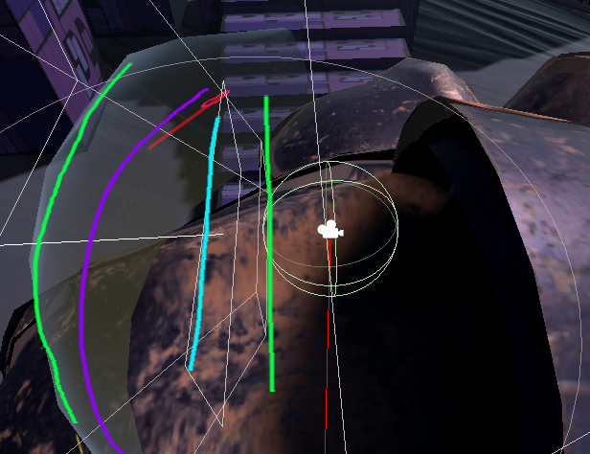*Figure 23: Heads Up Display rendering*

The green lines above represent the near clipping plane of the camera and the inside visor model. The light blue line is where the heads up display is rendered and the purple line is where the graphics from the heads up display are projected.

To make this projection of the objects on the heads up display I created a curved user interface using some tools I found on the unity forums [13]. The idea is to take an object on a 2D canvas and dynamically map the vertices of its mesh to the 3D locations it would correspond to on an imaginary cylinder. You can find more details on how that is done in the TesselationVertexEffect and CylinderMapping scripts in the CurvedUI directory. The next piece to making this holographic projection come to life is to use a custom shader to render the object in this new location. You can also find more details on this custom shader created by Unity forum user Gibbonator in the UI-Cylinder and CylinderMapping shaders in the CurvedUI directory.

## 

## Conclusion

There were many, many other changes and issues that were tackled in this project that did not fit into this document. For more information on other design decisions see the source code and if you have any questions feel free to contact me.

I also wanted to conclude with some of the comments from people testing the beta game and how design changes that were made due to this. The HUD originally only had the player health but players found this useful information to have without needing to look up on the wall menus to find, so this change was added in. The HUD objects were actually originally rendered outside of the helmet and players found that this would clip with the environment when turning fast so it was moved into the helmet to make it more realistic. The inside and outside visor material and texture was also notably lacking to some players and due to this, the material and texture selection was iterated over multiple times. In the future I would like to have a larger library of textures and with some more knowledge on realistic texturing the look and feel of the visor could be improved. Some more casual gamers or gamers with less experience in FPS games found the difficulty to be too hard. In the future I would like to add a difficulty setting in the game menu to make the experience appropriate for this group of players.

As always with testing players found these bugs in the beta game, but two stood out that I attempted to tackle without success. The first issue is that the pointer renderer (the line showing where the player is pointing to on the menu from their controller) for the pause menu would not render when the game was paused. It seems that changing the order this script executes to using the Update() method in Unity did not fix this. The other issue is that players can bypass the level limit collider if they move in real world space (movement from the headset) through it. No matter what way I tried to reset the players position after falling out of the level limit nothing seemed to work. These bugs will be fixed in the future and I plan to continue development on this project.

The game for this semester project was designed and tested for Windows systems using the Oculus Rift, but much of the project was created using VR hardware independent and cross-platform methods. Steam VR may still work but was outside the scope of this build and was tested. In the future I plan to add support for Steam VR, Oculus Android, Vuforia, non-VR PC and PS4 / Xbox / Android / iOS. I also plan to incorporate multiplayer support.

The takeaway from this project should be that your scope for the project must fit your realistic capabilities to complete the task. In my case, I had a vision I wanted to make reality but did not have the experience to accomplish that in my timeframe. I took a lot of inspiration for the immersive perspective from Blizzard’s Overwatch and this project shows that it is possible to create an FPS in VR with a highly detailed hybrid model as the playable character, like they have done in their non-VR game.

Enjoy this project for yourself and Game On!

## References

[0]: [Terran vs Zerg](https://www.deviantart.com/tnounsy/art/Terran-vs-Zerg-409589925)

[1]: [Terran Space Marine](https://i.ytimg.com/vi/5MDhMT7-ago/maxresdefault.jpg)

[2]: [Zerg Hydralisk](https://liquipedia.net/commons/images/thumb/f/f6/Hydralisk_SC_Remastered_Art2.jpg/600px-Hydralisk_SC_Remastered_Art2.jpg)

[3]: [StarCraft Audio](https://www.youtube.com/watch?v=d2t80SV54dw)

[4]: [Oculus Rift S](https://www.oculus.com/rift-s/)

[5]: [Example Map1 (original)](https://i.imgur.com/QQ0K4.jpg)

[6]: [Elisey's Space Marine Model (original)](https://sketchfab.com/3d-models/starcraft-marine-c31fbfd9e94c4366bb335a408dbe6990)

[7]: [Example Map2 (original)](https://i.pinimg.com/originals/b7/e2/7d/b7e27de2731b39bebdfc30eef1764a06.jpg)

[8]: <https://github.com/Kanma/CASCExtractor>

[9]: <https://github.com/stante/blendm3>

[10]: <https://learn.unity.com/project/survival-shooter-tutorial>

[11]: <https://github.com/crgallac/VR_Survival_Shooter>

[12]: <https://www.youtube.com/watch?v=Pt3-mHBCoQk>

[13]: <https://forum.unity.com/threads/warp-bend-the-ui.283066/>

[14]: <https://www.youtube.com/watch?v=escwjnHFce0&t=94s>